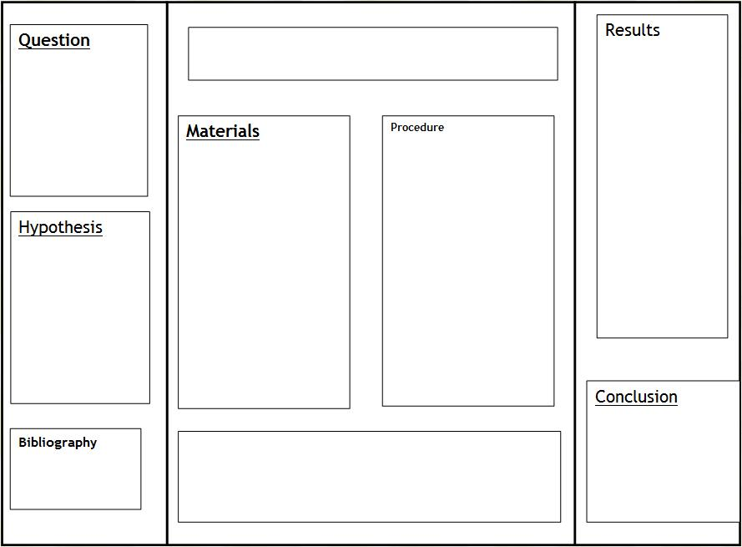

Conclusion

(Restate hypothesis, your findings, a lot to say here. Refer to sample handout investigation questions

Title

Pictures

Procedure

Written Results

(Talk only about graph results here

Data (Graphs)

Trial Two

Data (Graphs)

Trial One

Pictures

Hypotheses

Independent Variable

Dependent Variable

Control Variable

Materials

Question